**Checks and Questions XChange Box**

**Questions**

* What is the Hardware ID of your XChange box?
* What is not working? A detailed description of the problem needs to be done (Screenshots will be helpful)
* Tests to perform:
  + Ensure that both cables (data and voice) are well inserted.
  + Try to turn the device off and on again from the WebInterface of the XChange box.
  + Try to switch off the XChange box and switch it on again. Did this action solve the problem?
  + Try to switch off the terminal(s) used with the XChange box and switch it on again. Did this action solve the problem?
  + If this action changed the behavior or message, describe these changes in detail.
  + Was the box started correctly (can be tested by the captain when logging in the box)?
    - If no, ask someone to plug a screen on the XChange box and provide the error message.
  + In case the VSAT is not recognized by the box, confirm that the VSAT is plugged on the WAN2 of the box and on the correct port of the HP modem.

**Checks**

* Please remind that the box is a service so it’s working with a product which needs to be checked.
* Check Portal 360 for the status/logs/sync/version of the box.
* Refer to the photos below for the cable set up.
* Box1
* Box2
* Box3
* Box4
* **Box1**

Back to Top

* **Box2**

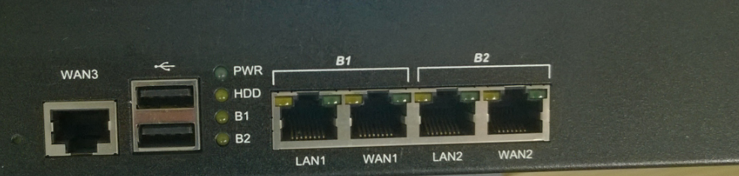

Back to Top

* **Box3**

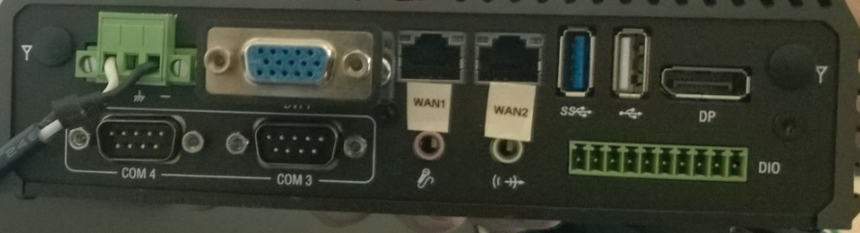

Back to Top

* A screenshot of a computer

  Description automatically generated with medium confidence**Box4**

Back to Top